Solder 5-wire ribbon cable to encoder reader and apply shrink tube



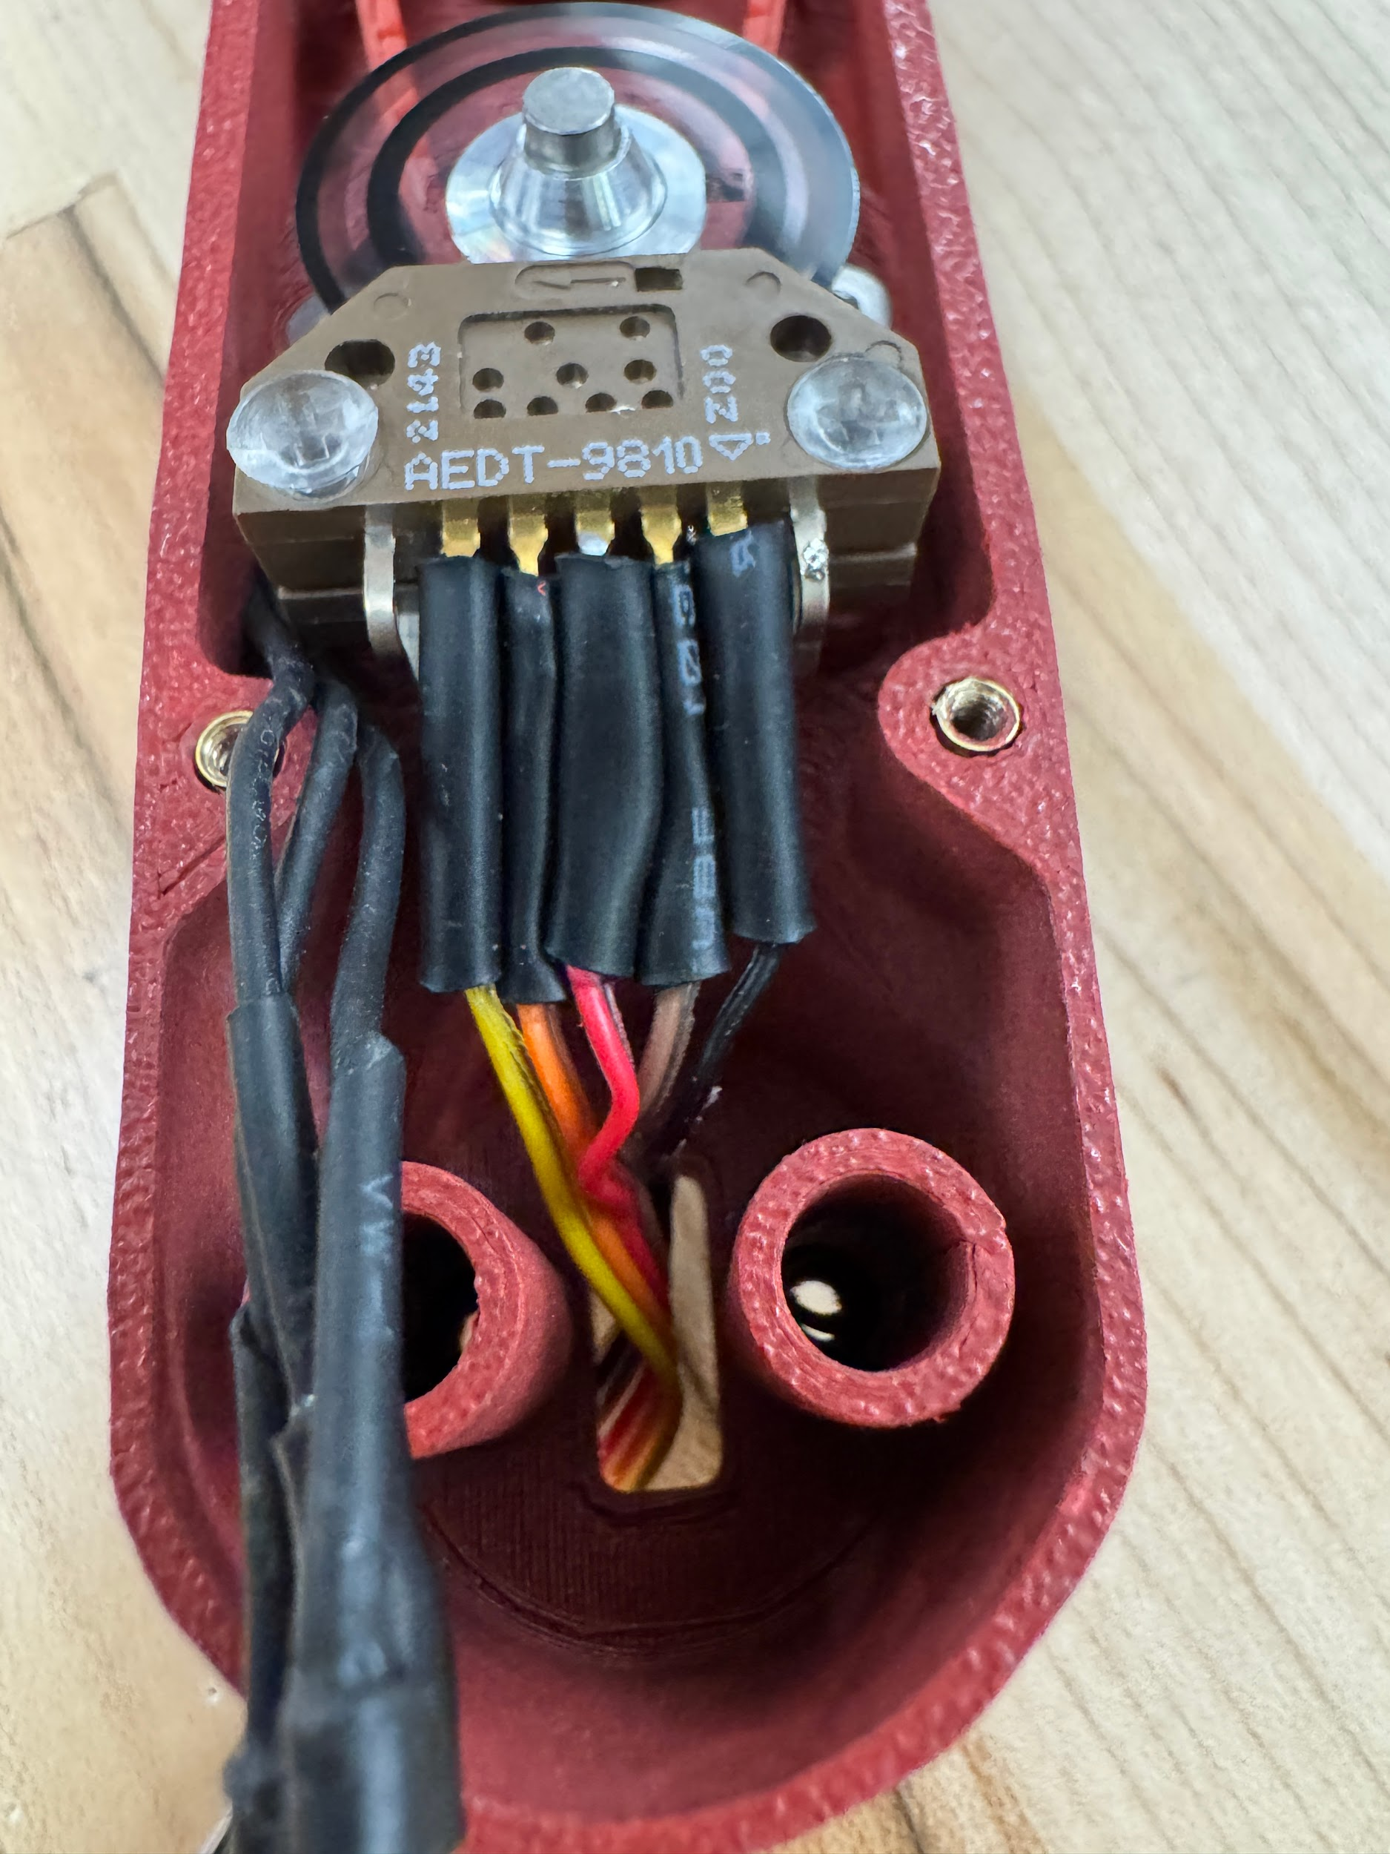

Connect 5-wire ribbon cable to Odrive side JST connector

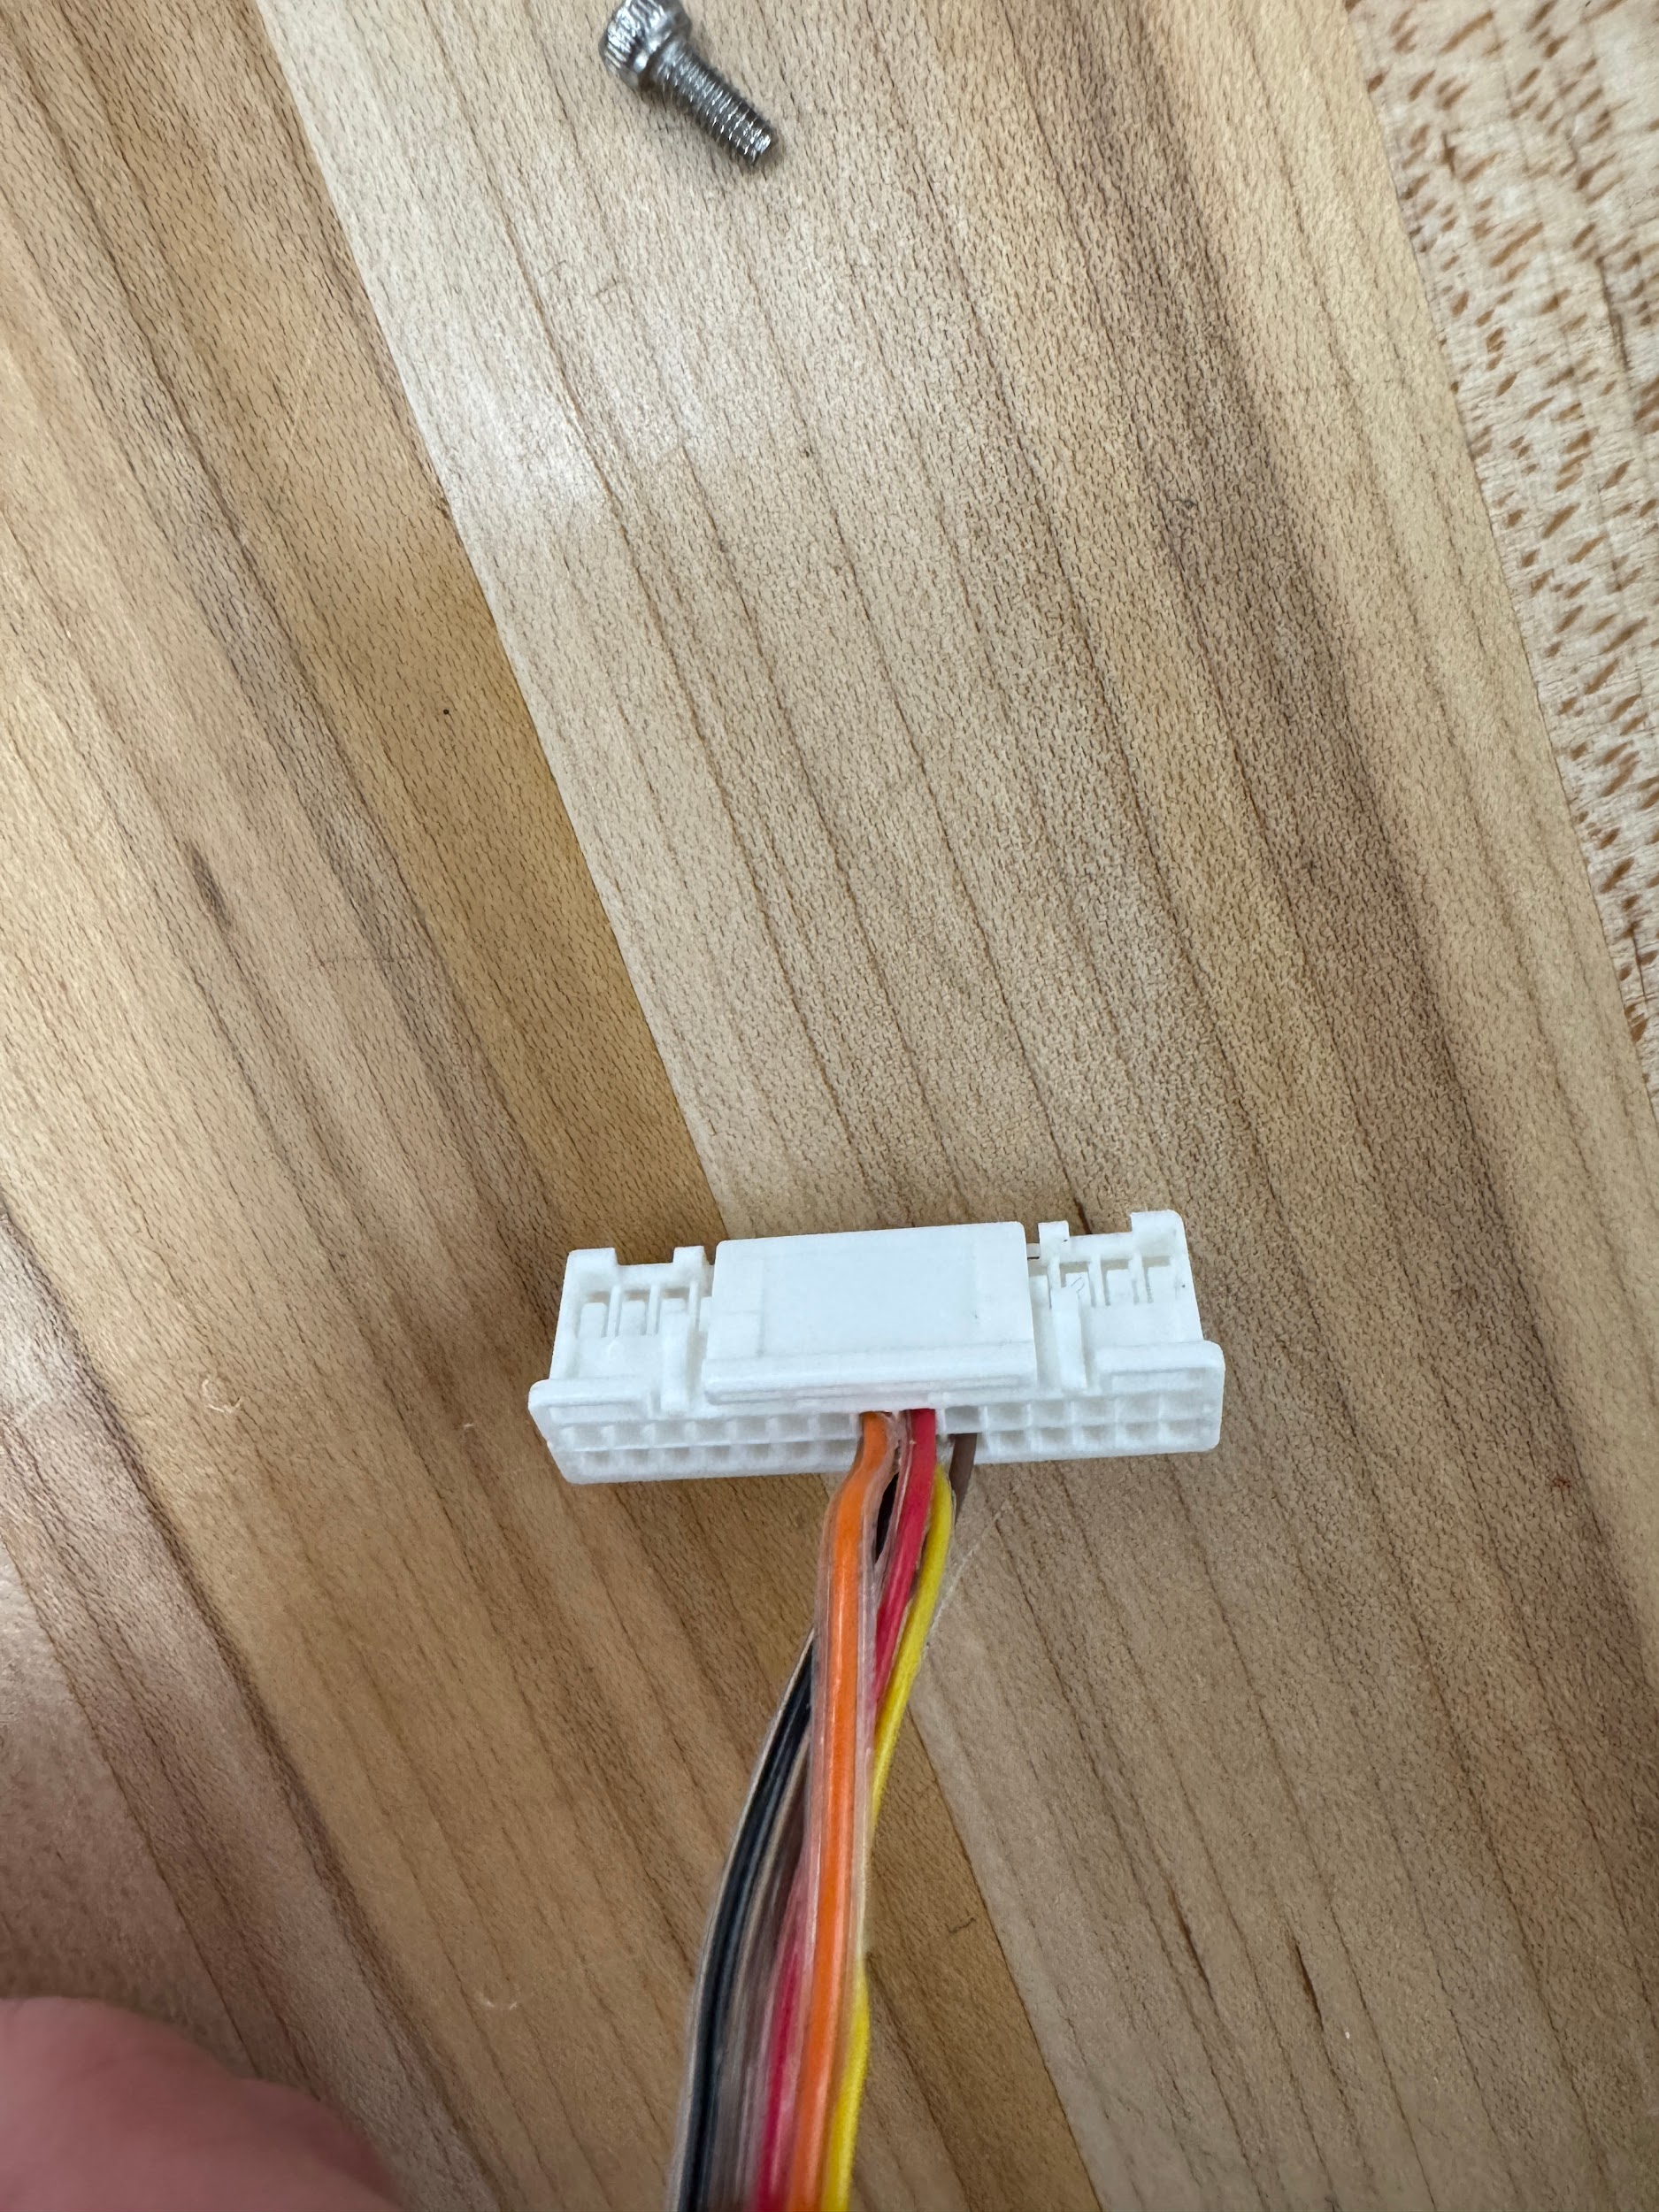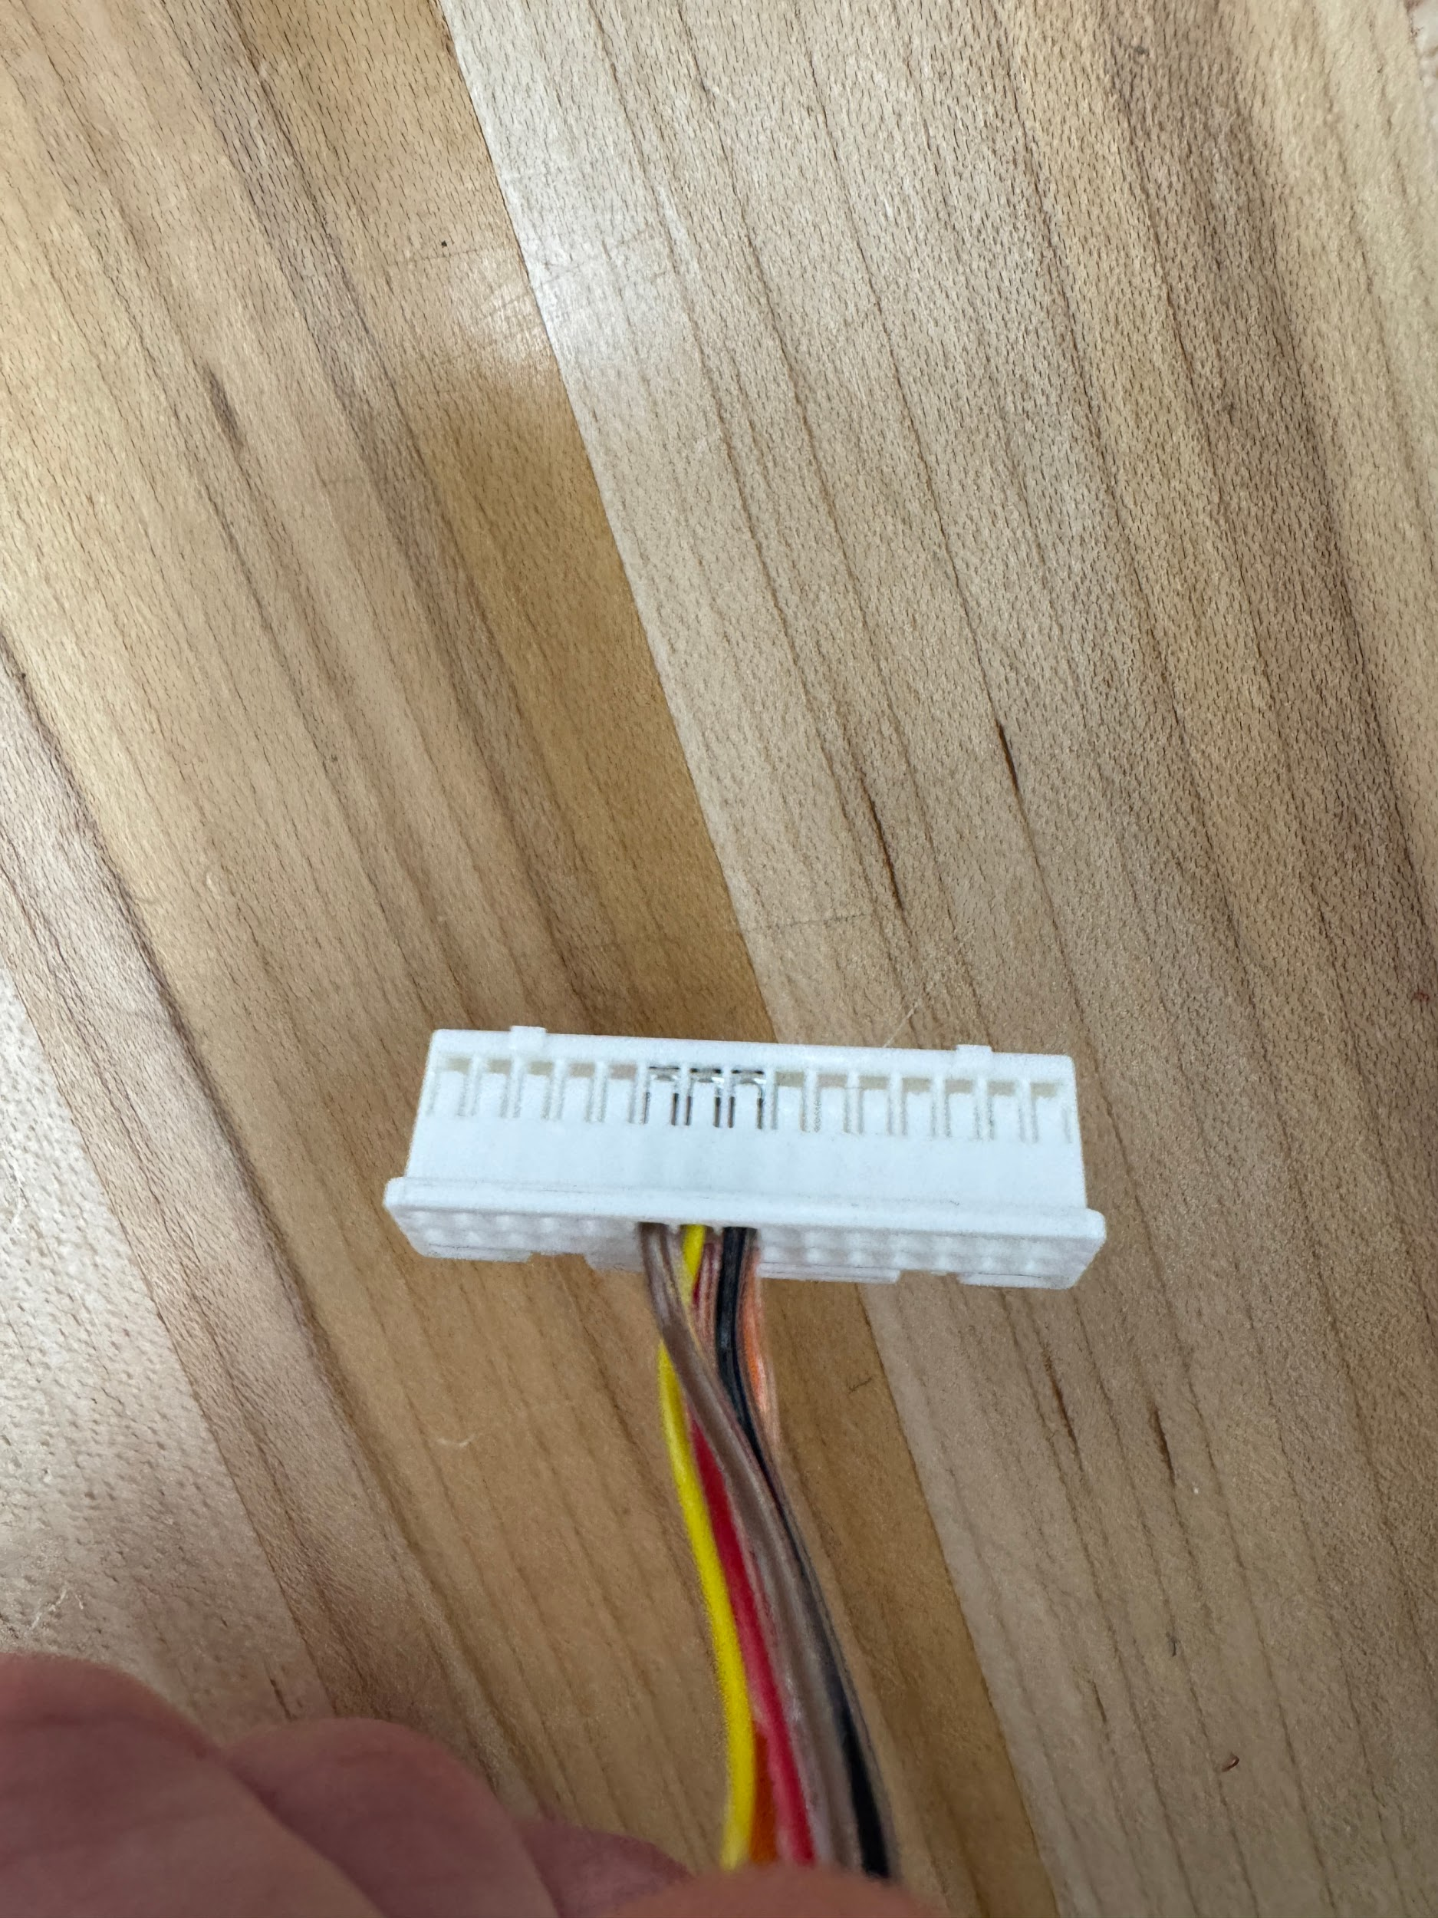

J11 connector from Odrive documentation

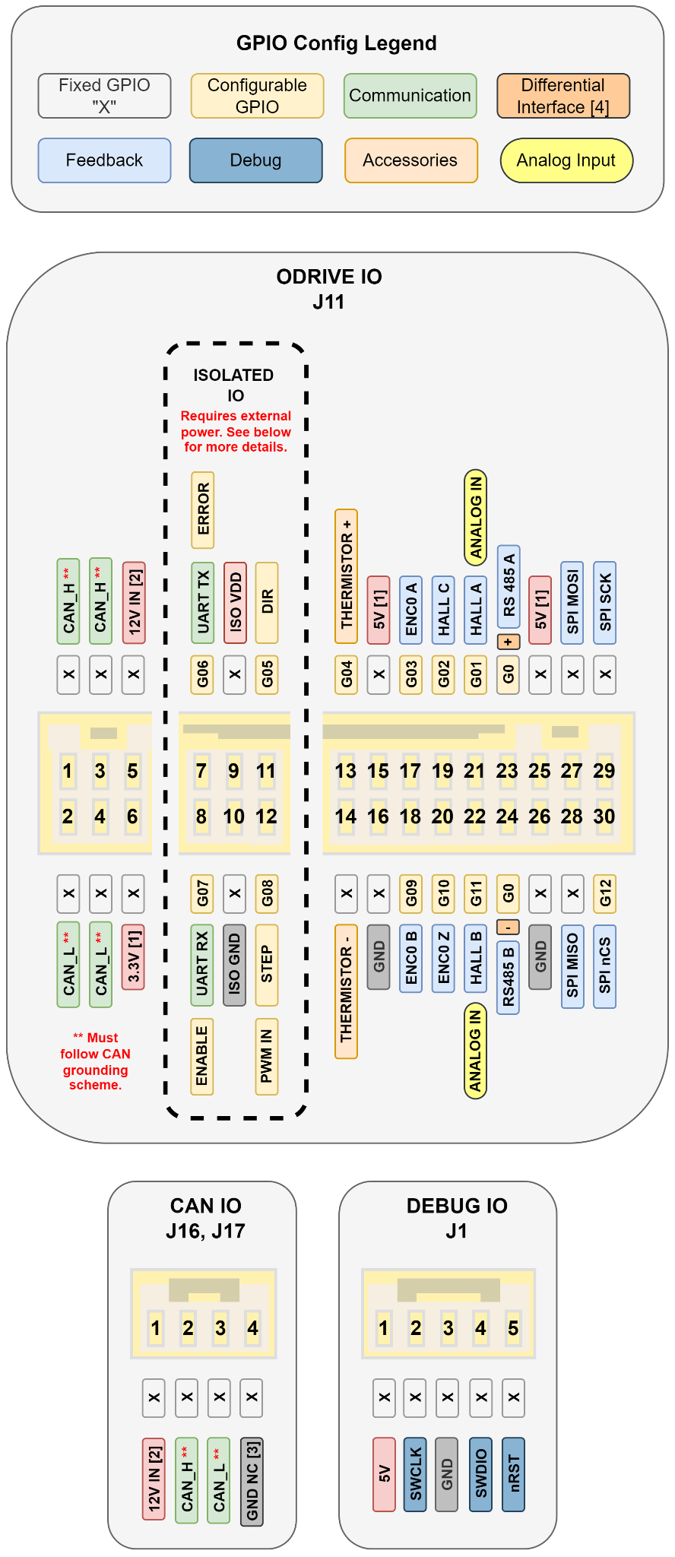

Plug J11 into Odrive

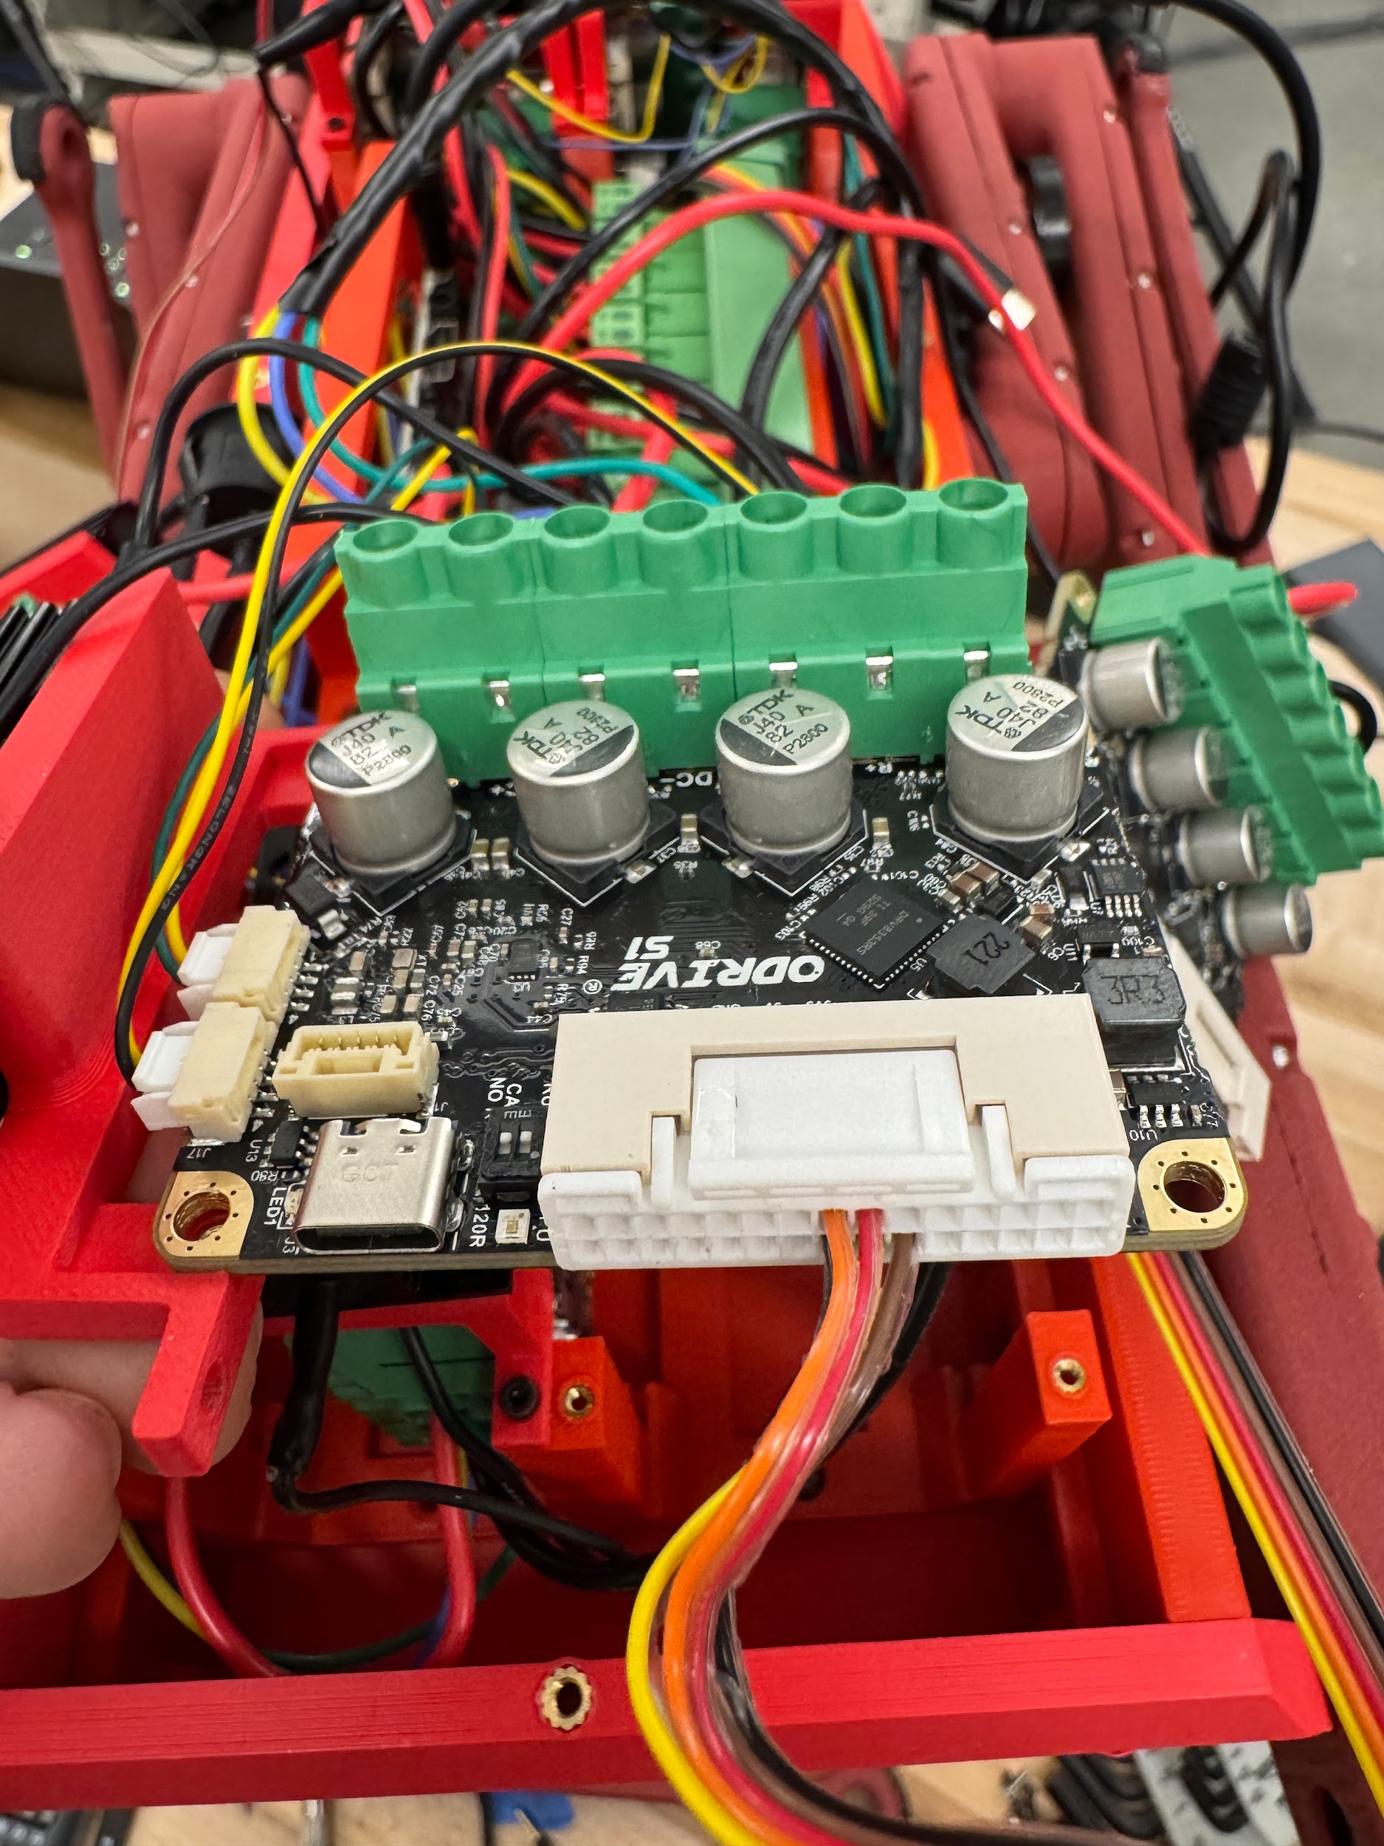

Assemble the phase wire cables with female banana connectors

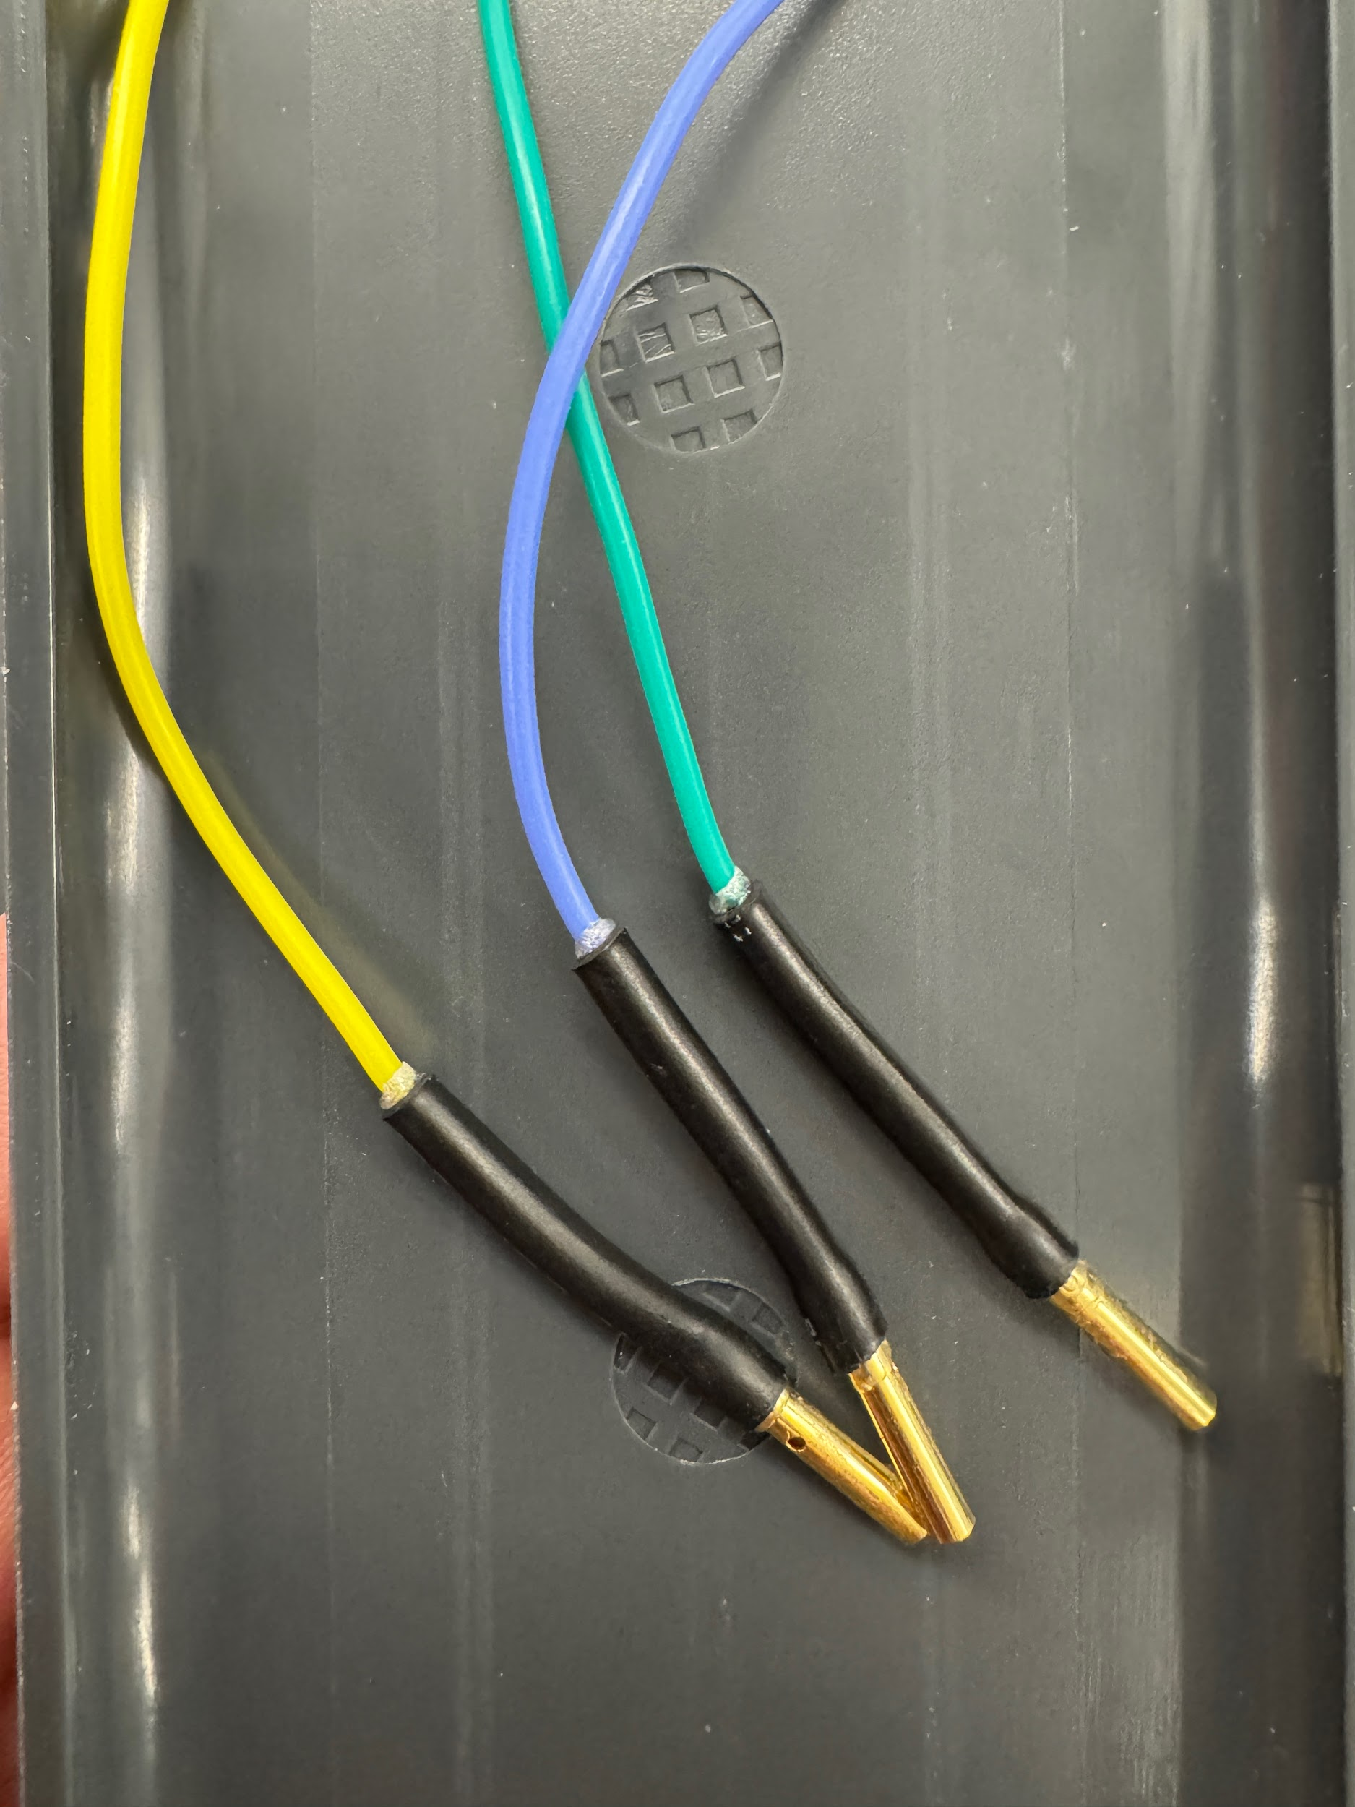

Connect three-phase wires to males leads on motor

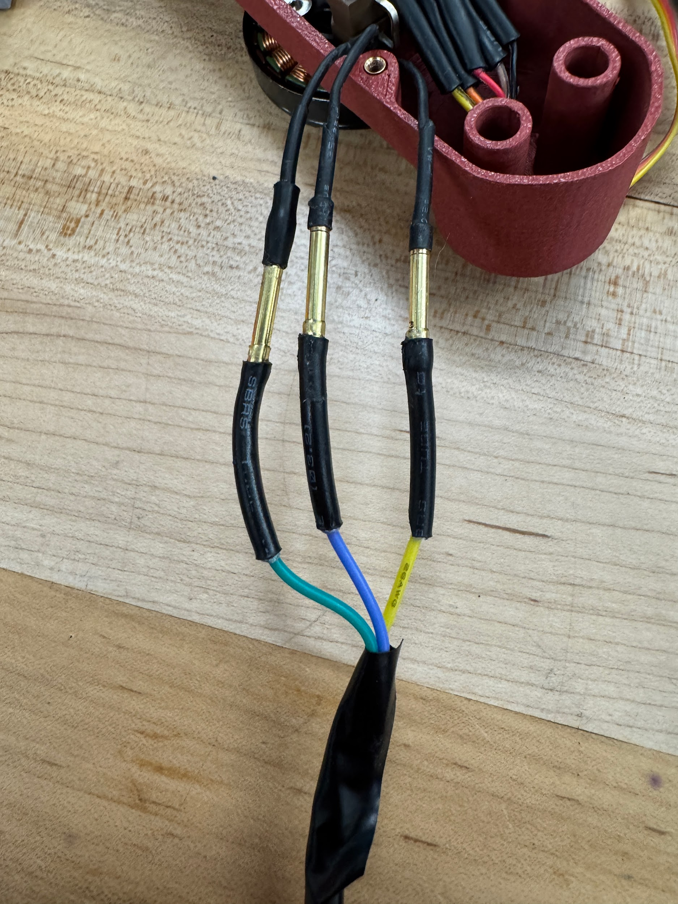

*Insulate the exposed copper with electrical tape to isolate the three phase wires, otherwise phases will interact causing the motor to jitter.

Create and plug in 4 pin CAN daisy chain cables

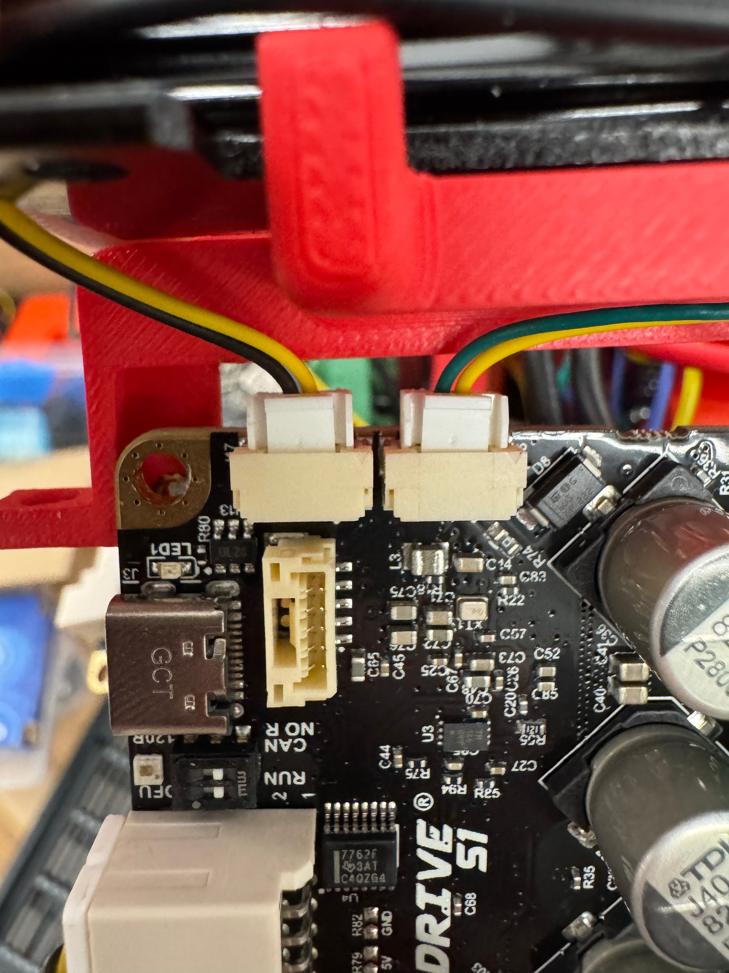

In image, CAN-L is left center pin, CAN-H is right center pin

*Premade cables found in spare parts need one end to be reversed otherwise CAN-L will connect to CAN-H



Connect braking resistor (BR), DC (18-24V) power, and motor phase wires to screw terminals

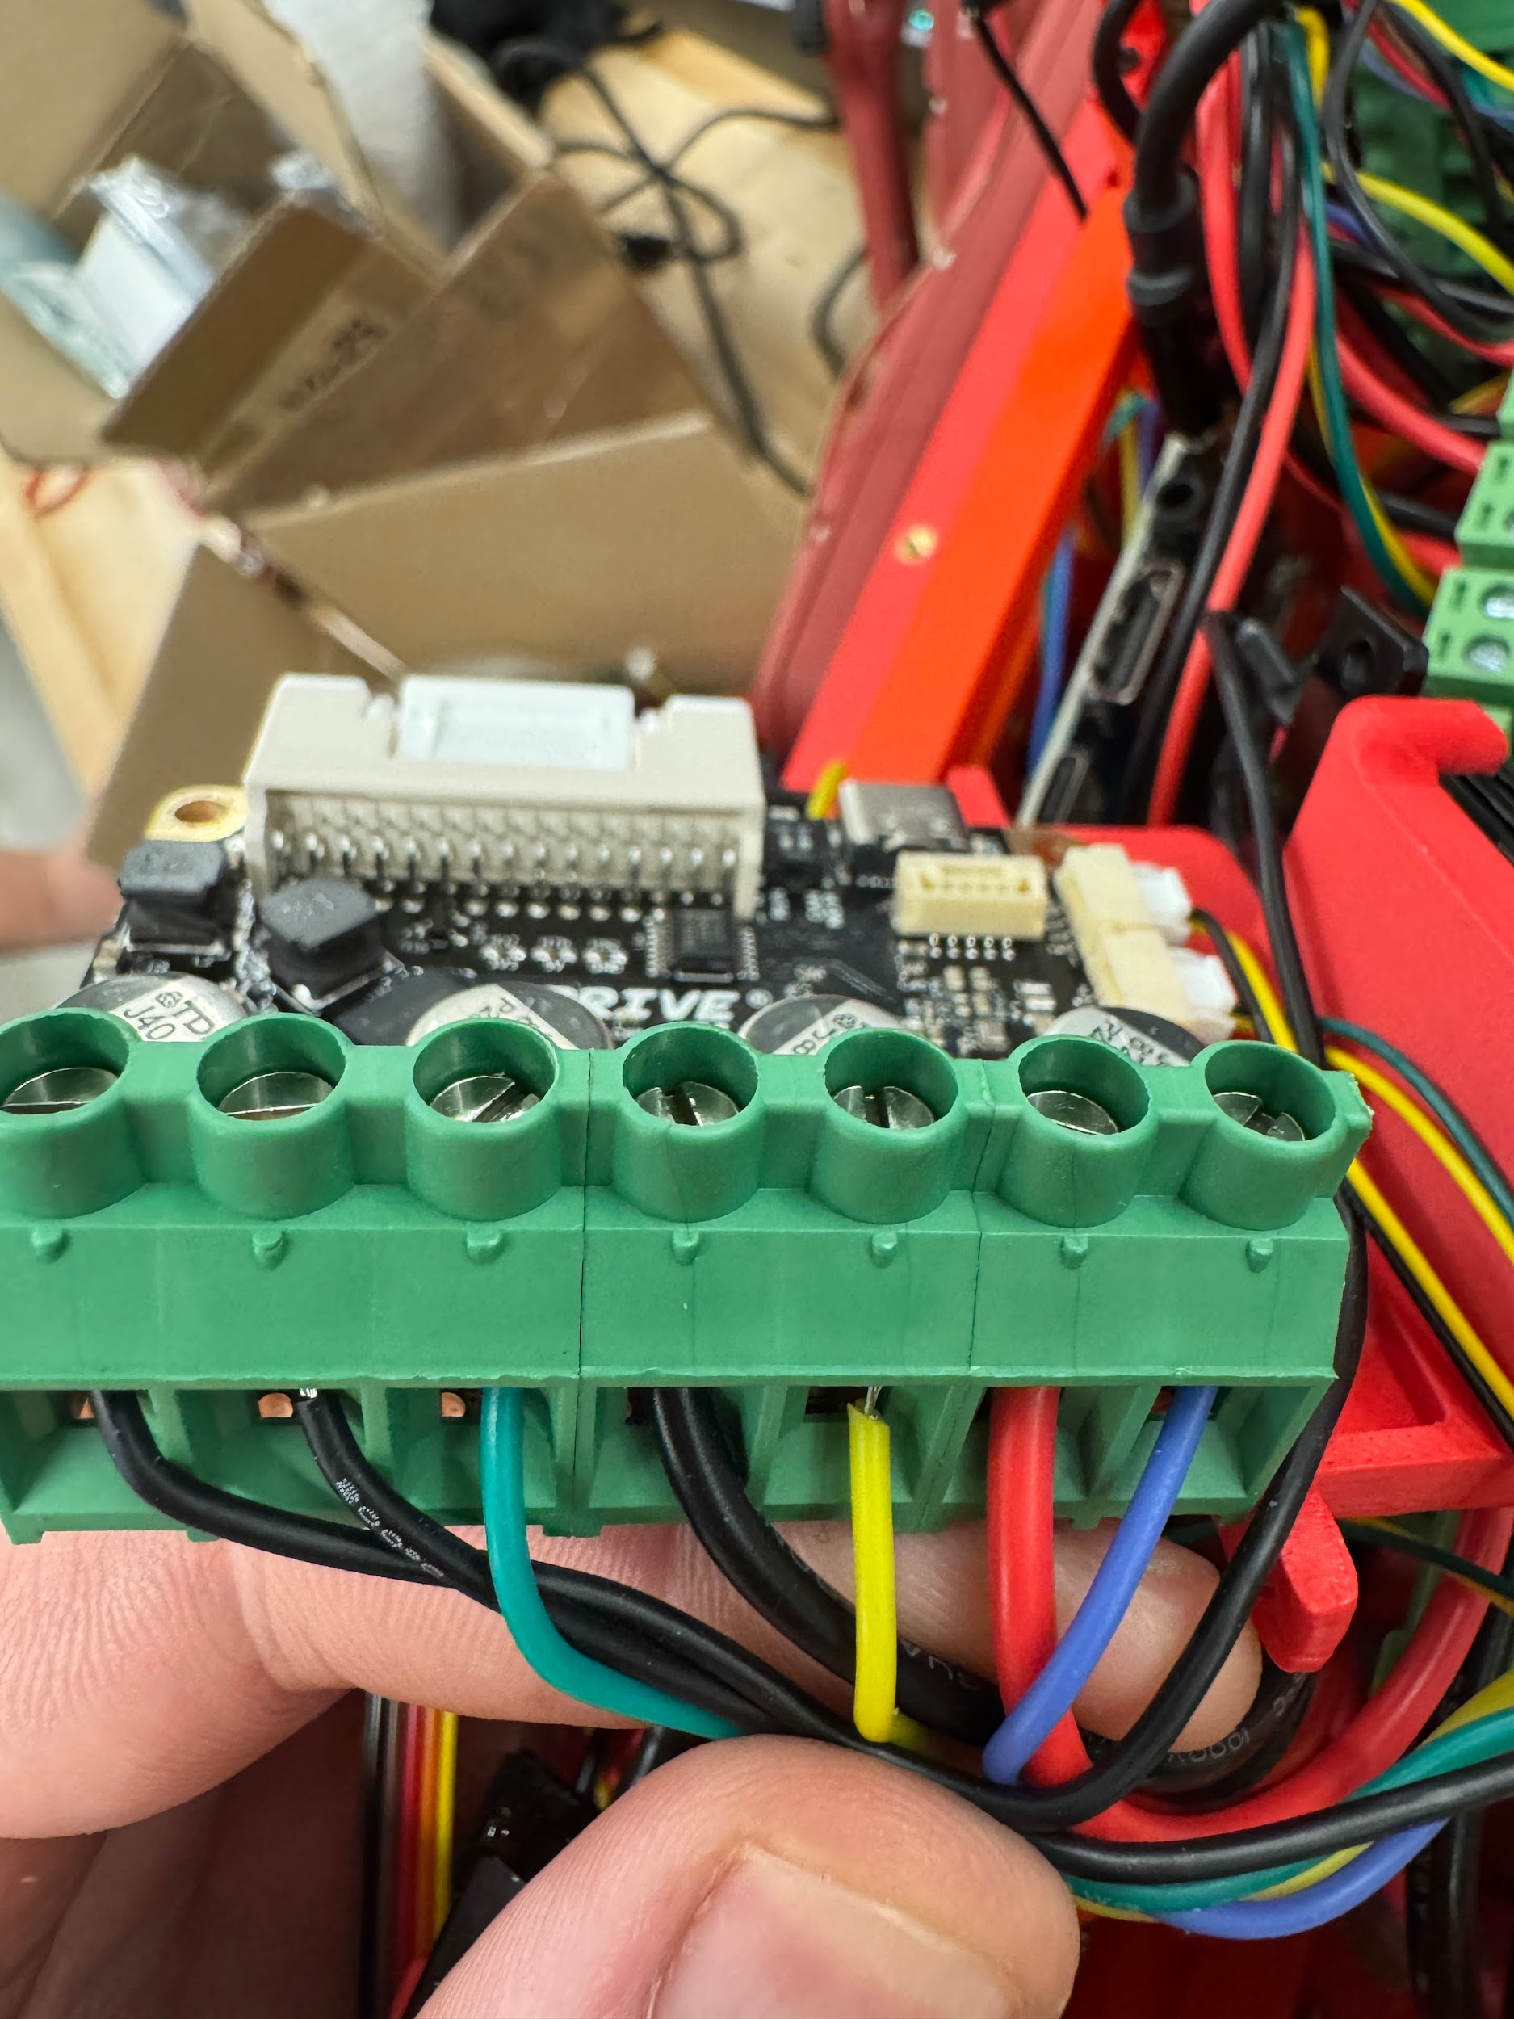



**Orange Pi 5 Connections**

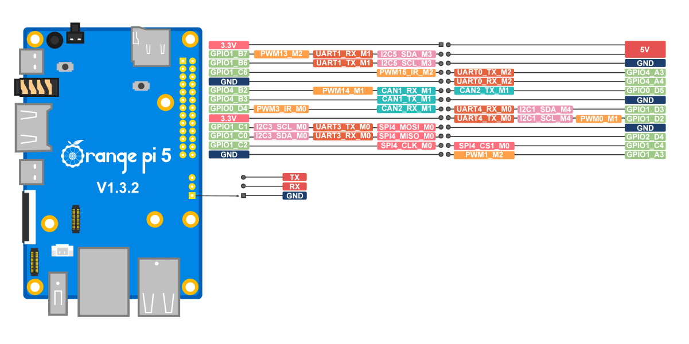

**OPi 5 Pins to CAN transceiver**

5V > Transceiver Power

CAN1_RX_M1 > Transceiver RX

CAN1_TX_M1 > Transceiver TX

Ground > Transceiver Ground

**OPi Pins to IMU**

5V > IMU Power

I2C5_SDA_M3 > IMU SDA

I2C5_M3 > IMU SCL

Ground > IMU Ground

Note: The CAN1 pins on the Orange Pi correspond to can0 in the software.

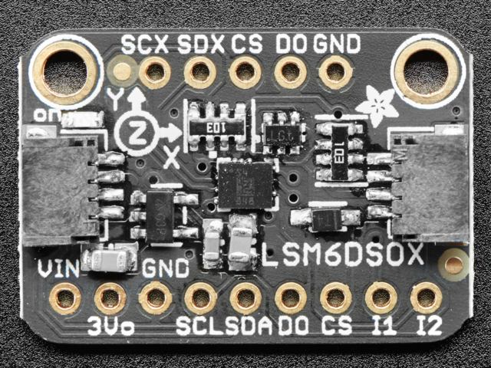

IMU

**Power Connections**

1. Spade connectors are crimped to black and red 18 AWG power wires, then pressed downward into the sockets in the battery adapter mounts in the body.

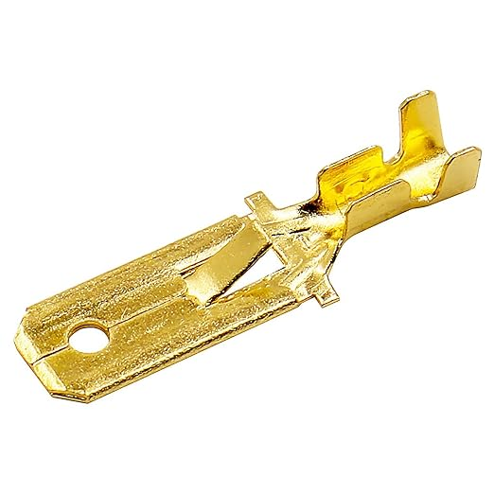

1. The two ground wires (black) are combined with a 2 to 1 splicer, same for the two hot (red) lines.

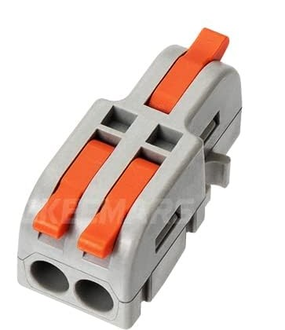

1. Connect power wires to one of the sets of input power on the power distribution board.

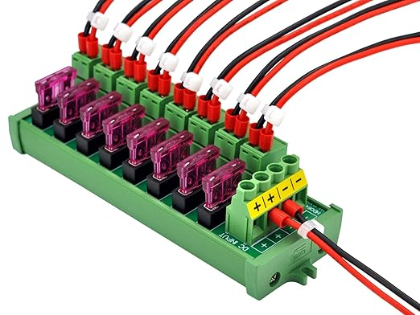

*The eight fuse protected outputs go directly to the ODrives from the previous step.

1. Power switch was spliced into the black wire and inserted into the rear socket in the body.



*The switch used was harvested from the unused milwaukee adapters.

1. Use the other two input terminals as outputs to power the 5V buck down DC DC power supply.

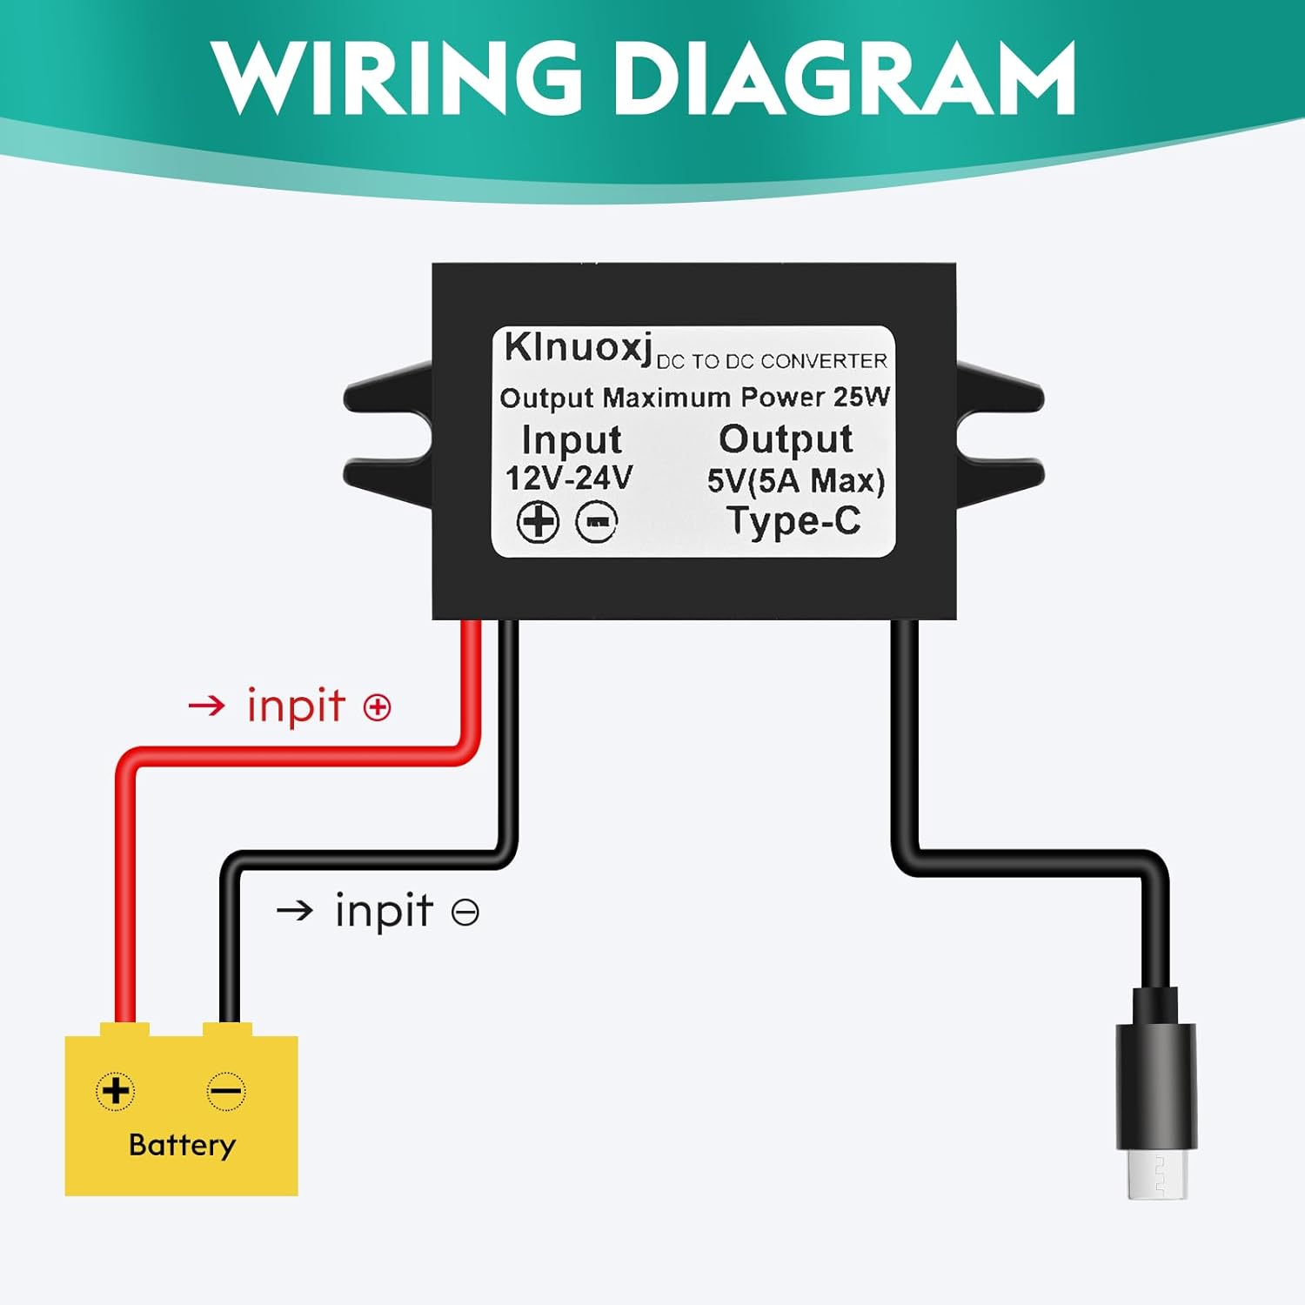

*USB-C output powers Orange Pi

1. Create another set of small gauge power wires for the cooling fan soldering them to the AMASS connector. Connect to any convenient screw terminal. Solder the other side of the AMASS connector to the fan power wires. Connect the AMASS connectors to power the fan.

